TEAM MEMBER 3
NARMATHA R
NMID DD9B45C050053DCA88E40F814D546E85

TEAM MEMBER 4
VISHINI K
NMID 8E201439FD7BA8185CD4E096D108E1F6

P R O J E C T D O C U M E N T A T I O N
CUSTOMER SUPPORT TICKET
PRIORITY PREDICTION AND
AUTOMATED ASSIGNMENT
SYSTEM
USING AGENTFORCE
Salesforce | Auto-Launched Flow | Agentforce
TEAM DETAILS
TEAM ID
TEAM SIZE
SWTID-2026-4146
5
TEAM LEADER
SUBASRI S
NMID
6C5C5456AAD6E18977B4CBF1F0BCB68D
TEAM MEMBER 1
MEENATCHI SUNDARI S
NMID
5029EE305301B2FA1CF4AA1F1A50DB0D
TEAM MEMBER 2
SUBIKSHA S
NMID
4D6DA7AAF00FEEC912E4D20104C4B4EB

A.V.C COLLEGE OF ENGINEERING
MANNAMPANDAL
COLLEGE CODE: 8203
Contents

1. Introduction . . . . . . . . . . . . . . . . . . . . . . . . . . . . . . . . . . . . . . . . . . . . . . . . . . . . . . 3
Project Overview . . . . . . . . . . . . . . . . . . . . . . . . . . . . . . . . . . . . . . . . . . . . . . . . . . . . . . . . . . . . 3
Purpose . . . . . . . . . . . . . . . . . . . . . . . . . . . . . . . . . . . . . . . . . . . . . . . . . . . . . . . . . . . . . . . . . . 3

2. Ideation Phase . . . . . . . . . . . . . . . . . . . . . . . . . . . . . . . . . . . . . . . . . . . . . . . . . . . . . 3
Problem Statements . . . . . . . . . . . . . . . . . . . . . . . . . . . . . . . . . . . . . . . . . . . . . . . . . . . . . . . . . . . 3
Empathy Map . . . . . . . . . . . . . . . . . . . . . . . . . . . . . . . . . . . . . . . . . . . . . . . . . . . . . . . . . . . . . . 4
Brainstorming and Idea Prioritization . . . . . . . . . . . . . . . . . . . . . . . . . . . . . . . . . . . . . . . . . . . . . . . . . 4

3. Requirement Analysis . . . . . . . . . . . . . . . . . . . . . . . . . . . . . . . . . . . . . . . . . . . . . . . . . 5
Customer Journey Map . . . . . . . . . . . . . . . . . . . . . . . . . . . . . . . . . . . . . . . . . . . . . . . . . . . . . . . . . 5
Solution Requirements . . . . . . . . . . . . . . . . . . . . . . . . . . . . . . . . . . . . . . . . . . . . . . . . . . . . . . . . . 6
Data Flow . . . . . . . . . . . . . . . . . . . . . . . . . . . . . . . . . . . . . . . . . . . . . . . . . . . . . . . . . . . . . . . . . 6
Technology Stack . . . . . . . . . . . . . . . . . . . . . . . . . . . . . . . . . . . . . . . . . . . . . . . . . . . . . . . . . . . . 7

4. Project Design . . . . . . . . . . . . . . . . . . . . . . . . . . . . . . . . . . . . . . . . . . . . . . . . . . . . . 7
Problem-Solution Fit . . . . . . . . . . . . . . . . . . . . . . . . . . . . . . . . . . . . . . . . . . . . . . . . . . . . . . . . . . 7
Proposed Solution . . . . . . . . . . . . . . . . . . . . . . . . . . . . . . . . . . . . . . . . . . . . . . . . . . . . . . . . . . . . 8
Solution Architecture . . . . . . . . . . . . . . . . . . . . . . . . . . . . . . . . . . . . . . . . . . . . . . . . . . . . . . . . . . 8

5. Project Planning and Scheduling . . . . . . . . . . . . . . . . . . . . . . . . . . . . . . . . . . . . . . . . . . . 8
Planning Approach . . . . . . . . . . . . . . . . . . . . . . . . . . . . . . . . . . . . . . . . . . . . . . . . . . . . . . . . . . . 8
Product Backlog and Sprint Schedule . . . . . . . . . . . . . . . . . . . . . . . . . . . . . . . . . . . . . . . . . . . . . . . . . 9
Sprint Tracker and Velocity . . . . . . . . . . . . . . . . . . . . . . . . . . . . . . . . . . . . . . . . . . . . . . . . . . . . . . 10

6. Project Development . . . . . . . . . . . . . . . . . . . . . . . . . . . . . . . . . . . . . . . . . . . . . . . . 10
Milestone 1: Salesforce Environment . . . . . . . . . . . . . . . . . . . . . . . . . . . . . . . . . . . . . . . . . . . . . . . . 10
Milestone 2: Data Model . . . . . . . . . . . . . . . . . . . . . . . . . . . . . . . . . . . . . . . . . . . . . . . . . . . . . . . 12
Milestone 3: Auto-Launched Flow . . . . . . . . . . . . . . . . . . . . . . . . . . . . . . . . . . . . . . . . . . . . . . . . . . 14
Milestone 4: Making the Object Available in the Sales App . . . . . . . . . . . . . . . . . . . . . . . . . . . . . . . . . . . . 16
Milestone 5: Agentforce Configuration . . . . . . . . . . . . . . . . . . . . . . . . . . . . . . . . . . . . . . . . . . . . . . . 17
7. Functional and Performance Testing . . . . . . . . . . . . . . . . . . . . . . . . . . . . . . . . . . . . . . . . 20

8. Advantages and Disadvantages . . . . . . . . . . . . . . . . . . . . . . . . . . . . . . . . . . . . . . . . . . . 21
Advantages . . . . . . . . . . . . . . . . . . . . . . . . . . . . . . . . . . . . . . . . . . . . . . . . . . . . . . . . . . . . . . . 21
Disadvantages . . . . . . . . . . . . . . . . . . . . . . . . . . . . . . . . . . . . . . . . . . . . . . . . . . . . . . . . . . . . . 21
- Conclusion . . . . . . . . . . . . . . . . . . . . . . . . . . . . . . . . . . . . . . . . . . . . . . . . . . . . . . 22
- Future Scope . . . . . . . . . . . . . . . . . . . . . . . . . . . . . . . . . . . . . . . . . . . . . . . . . . . . 22

11. Appendix . . . . . . . . . . . . . . . . . . . . . . . . . . . . . . . . . . . . . . . . . . . . . . . . . . . . . . 22
1
INTRODUCTION

Project Overview
Support teams handle a steady stream of tickets, and deciding which ones need attention first is usually done by hand. This project replaces that manual step with a Salesforce solution. A custom object called Support Ticket Intelligence stores each ticket, an Auto-Launched Flow reads the latest ticket of a customer Account and classifies it as High, Medium or Low priority, and an Agentforce subagent lets a support user trigger the whole process by simply typing an Account Name.
When a ticket is classified as High, the flow also creates an urgent handling task and routes the ticket to a senior support agent, so critical issues stop waiting in the queue.

Purpose
- Classify support tickets as High, Medium or Low priority without manual review.
- Fetch the most recent ticket that belongs to a given customer Account.
- Create an Urgent Ticket Handling task automatically for High-priority tickets.
- Assign the right support level (for example, a senior agent for urgent cases).
- Give support users a conversational way to run the analysis through Agentforce.
- Cut response time and the repetitive effort spent on triage.
2
IDEATION PHASE

Problem Statements
The table below records the problems that motivated the project, written from the point of view of each person affected.
# | I am | I am trying to | But | Because | Which makes me  feel
PS-1 | A support agent | Focus on critical tickets first | Tickets are not always  prioritized automatically | Prioritization is largely  manual | Frustrated
PS-2 | A customer | Get urgent issues resolved quickly | Critical issues can wait behind minor ones | Teams handle very large ticket volumes | Concerned
PS-3 | A support manager | Assign tickets to the right support  level | Assignment needs manual decisions | Urgency is not analyzed consistently | Overwhelmed
PS-4 | A support agent | Spot urgent issues from descriptions | Important keywords get missed | Descriptions carry different urgency  signals | Uncertain
PS-5 | A support manager | Reduce  SLA-related risk | Older unresolved tickets go unnoticed | SLA risk needs an extra check | Concerned
Summary of needs. High ticket volume, manual prioritization, wrong or slow assignment, delayed resolution and a poor customer experience all point to one need: a smart, automated system that classifies priority, routes tickets and shortens response time.

Empathy Map
Persona: Support Agent. The map captures what the agent experiences while working through the queue.
THINKS & FEELS |  | HEARS
Wants critical issues identified quickly so urgent customer problems get attention. |  | Customer issue descriptions and support requests arriving all day.
SEES |  | SAYS & DOES
Ticket status, issue type, description, priority level, assignment and SLA risk. |  | Reviews tickets, handles assigned cases and focuses on urgent support issues.
PAINS |  | GAINS
Manual prioritization, missed urgency signals and delays in handling critical tickets. |  | Automatic priority classification, clearer assignment, urgent-task creation and less manual effort.

Brainstorming and Idea Prioritization
Four approaches were considered: manual ticket registers, spreadsheet-based tracking, a standalone support portal, and Salesforce CRM combined with Agentforce. Ideas were then placed on an impact-versus-feasibility grid.
 | LOW FEASIBILITY | HIGH FEASIBILITY
HIGH  IMPACT | High impact, low feasibility  - Use AI to classify ticket priority  - Customer sentiment analysis for urgency | High impact, high feasibility  - Automatically assign tickets to the right agent  - Real-time notifications for urgent tickets  - SLA breach alerts  - Dashboards for ticket trends
LOW  IMPACT | Low impact, low feasibility  • Mobile access for support agents | Low impact, high feasibility  - Self-service FAQs  - Automatic email updates  - Knowledge article suggestions  - Automation to update status  - Balance workload across agents
Top prioritized ideas: AI-based priority classification, automatic ticket assignment, real-time notifications, dashboards and reporting, and SLA breach alerts.

Final Selection
Salesforce CRM with Agentforce was chosen because it offers:
- Automation through Salesforce Flow
- AI-assisted ticket analysis through Agentforce
- Automatic priority classification
- Automatic urgent-task creation
- Less manual support effort
3
REQUIREMENT ANALYSIS

Customer Journey Map
A ticket moves through eight stages, from the moment a customer reports an issue to the feedback collected after resolution.
Stage | Customer action | System / AI action | Outcome
1. Raise ticket | Submits a ticket with issue details | Creates the ticket record in Salesforce | Ticket created
2. Ticket received | Waits for confirmation | Stores the ticket and triggers automation | Ticket logged
3. AI analysis | No direct action | Analyzes the description and classifies priority | Priority identified
4. Auto assignment | No direct action | Assigns the ticket to the right agent | Ticket assigned
5. Agent works | May add information | Agent updates status, adds notes, resolves | Issue resolved
6. Updates | Receives status updates | Sends automated notifications | Customer informed
7. Resolved | Confirms resolution | Closes the ticket | Ticket closed
8. Feedback | Shares feedback and rating | Captures feedback for improvement | Insights gathered

Solution Requirements

Functional requirements
FR No | Requirement
FR-1 | Support ticket creation and management
FR-2 | Account and Contact association
FR-3 | Ticket description analysis
FR-4 | Automatic priority classification
FR-5 | High-priority task creation
FR-6 | Support agent assignment
FR-7 | SLA breach risk checking
FR-8 | Agentforce conversational analysis

Non-functional requirements
Attribute | Description
Usability | Clear Agentforce interaction and easy-to-read priority messages
Reliability | Consistent classification based on the configured conditions
Performance | Quick retrieval and analysis of the latest support ticket
Security | Controlled Salesforce access to customer and ticket information
Maintainability | Flow and Agentforce configuration can be updated without redevelopment
Scalability | Handles growing ticket volumes through Salesforce automation

Data Flow
From the request to the final response, data moves through the following stages:
Customer / support
request
Account
Latest support ticket
Ticket description
Analyze description
Priority level
High / Medium / Low
decision
Task + agent assignment
Through Agentforce the same path starts with a conversation:
User gives Account Name
Agentforce subagent
Auto-Launched Flow
Ticket analysis
Priority and assignment output
Response to user

Technology Stack
Layer | Technology
Platform | Salesforce (Developer Edition and Trailhead Playground orgs)
Data | Support_Ticket_Intelligence__c, with Account, Contact, User and Task records
Logic | Auto-Launched Flow
AI | Agentforce (Default) with a custom subagent
Agent configuration | Support Ticket Priority Analysis subagent
Automation | Flow Decision, Assignment and Create Records elements
Output | Agentforce conversation response
4
PROJECT DESIGN

Problem-Solution Fit
Problem | Solution | Benefit
Manual ticket prioritization | Flow analyzes the description and sets priority | Faster identification of urgent cases
Urgent issues may be missed | High-priority keyword decision | Critical cases get attention
Manual task creation | Flow creates a Task for High priority | Less manual effort
Manual support assignment | Flow sets the assigned support level | More consistent handling
SLA risk can be overlooked | Optional SLA risk decision | Better risk awareness
Need for conversational access | Agentforce subagent interaction | AI-assisted usage

Proposed Solution
Parameter | Description
Problem | Manual prioritization and assignment delays the handling of critical customer support issues.
Solution | A Salesforce-based ticket priority prediction and automated assignment system.
Innovation | Agentforce AI combined with an Auto-Launched Flow to analyze descriptions, classify priority, assign a support level and trigger urgent-task automation.
Impact | Critical tickets are found sooner, manual effort drops, response time improves and the team is more productive.
Business model | Customer support operations involving customers, agents, managers and AI-assisted ticket handling.
Scalability | Scales with ticket volume through Salesforce automation, with room for more assignment rules, SLA monitoring and priority indicators.

Solution Architecture
The solution is organized in four layers. A request enters through Agentforce, the Auto-Launched Flow does the analysis, and Salesforce records hold the data and the results.
Users
Support agents
Support managers
Customers (via tickets)
AI layer
Agentforce (Default)
Support Ticket Priority
Analysis subagent
Flow-based agent action
Automation layer
Get Account / Get Ticket
Analyze Description decision
Create Task, assign agent, set
message
Data layer
Account and Contact
Support_Ticket_Intelligence__c
Task and User
5
PROJECT PLANNING AND SCHEDULING
Planning Approach
- Agile methodology with sprint-based execution
- Epics are broken into user stories and sized in story points
- Velocity is calculated from completed story points and used for estimation

Product Backlog and Sprint Schedule
Sprint | Epic | USN | User story / task | Pts | Priority | Owner
1 | Developer setup | USN-1 | As a system administrator, I want to configure the Salesforce environment for Support Ticket Intelligence so the automation can be developed. | 3 | High | Caroline Hansika  L
2 | Data modeling | USN-2 | As an admin, I want to create the Support Ticket Intelligence object with the required fields and relationships so ticket data is stored systematically. | 5 | High | Sindhuja S
2 | Data modeling | USN-3 | As a support user, I want tickets associated with Accounts and Contacts so the latest ticket of a customer can be identified. | 3 | High | Preethi S
3 | Automation | USN-4 | As a support agent, I want an  Auto-Launched Flow to retrieve the latest ticket and analyze its description so priority can be set automatically. | 5 | High | Caroline Hansika  L
3 | Automation | USN-5 | As a support agent, I want tickets classified as High, Medium or Low from configured urgency conditions so critical issues are handled first. | 5 | High | Sindhuja S
4 | Agentforce and automation | USN-6 | As an AI agent, I want to analyze ticket details and trigger the backend Flow so manual prioritization is reduced. | 8 | High | Caroline Hansika  L
4 | Task and assignment | USN-7 | As a support manager, I want High-priority tickets to create an urgent task and be assigned to the right support level. | 5 | High | Preethi S
5 | SLA manage ment | USN-8 | As a support manager, I want the system to check SLA breach risk for older unresolved tickets. | 5 | Medium | Sindhuja S
6 | Conversatio nal support | USN-9 | As a support user, I want to give an  Account Name to Agentforce and receive the ticket ID, priority, assigned agent and action message. | 5 | Medium | Preethi S
Story-point total: 44 across six sprints (3 + 8 + 10 + 13 + 5 + 5).

Sprint Tracker and Velocity
Sprint | Story points | Duration | Start date | Planned end | Points completed | Release date
Sprint-1 | 3 | 3 days | 14 Sep 2026 | 16 Sep 2026 | 3 | 16 Sep 2026
Sprint-2 | 8 | 3 days | 17 Sep 2026 | 19 Sep 2026 | 8 | 19 Sep 2026
Sprint-3 | 10 | 3 days | 21 Sep 2026 | 23 Sep 2026 | 10 | 23 Sep 2026
Sprint-4 | 13 | 3 days | 24 Sep 2026 | 26 Sep 2026 | 13 | 26 Sep 2026
Sprint-5 | 5 | 3 days | 28 Sep 2026 | 30 Sep 2026 | 5 | 30 Sep 2026
Sprint-6 | 5 | 3 days | 01 Oct 2026 | 03 Oct 2026 | 5 | 03 Oct 2026
Average velocity = total story points / total sprint days = 44 / 18 = 2.44 points per day (about 7.3 points per sprint).
Sprint Burndown (story points remaining)
0
11
22
33
44
Start
S1
S2
S3
S4
S5
S6
Ideal
Actual
6
PROJECT DEVELOPMENT
The topics covered while building the solution were data modeling, fields and relationships, the Lightning App Builder, Salesforce Flow and Agentforce configuration.

Milestone 1: Salesforce Environment

Activity 1: Create the Trailhead Playground
A hands-on org was created from the Hands-On Orgs page in Trailhead using Create Playground. The project org, Customer Support Ticket Priority, is listed alongside the existing playground.
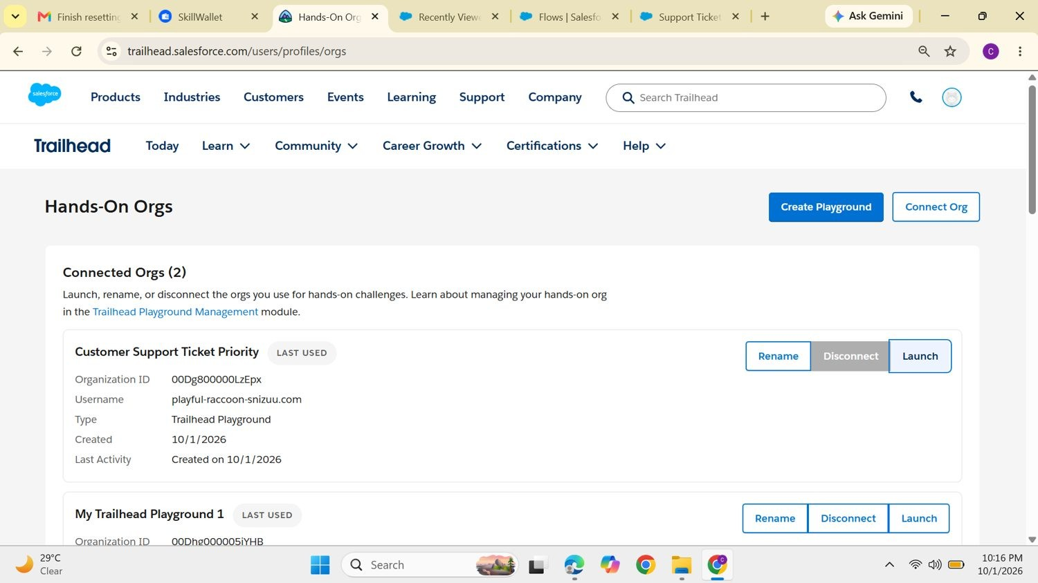
Figure 1. Trailhead Hands-On Orgs page listing the connected orgs, with the project playground "Customer Support Ticket Priority".

Activity 2: Launch the org
Selecting Launch opens the org and signs in as the team leader, Caroline Hansika L. The Playground Starter app opens on its Welcome page.
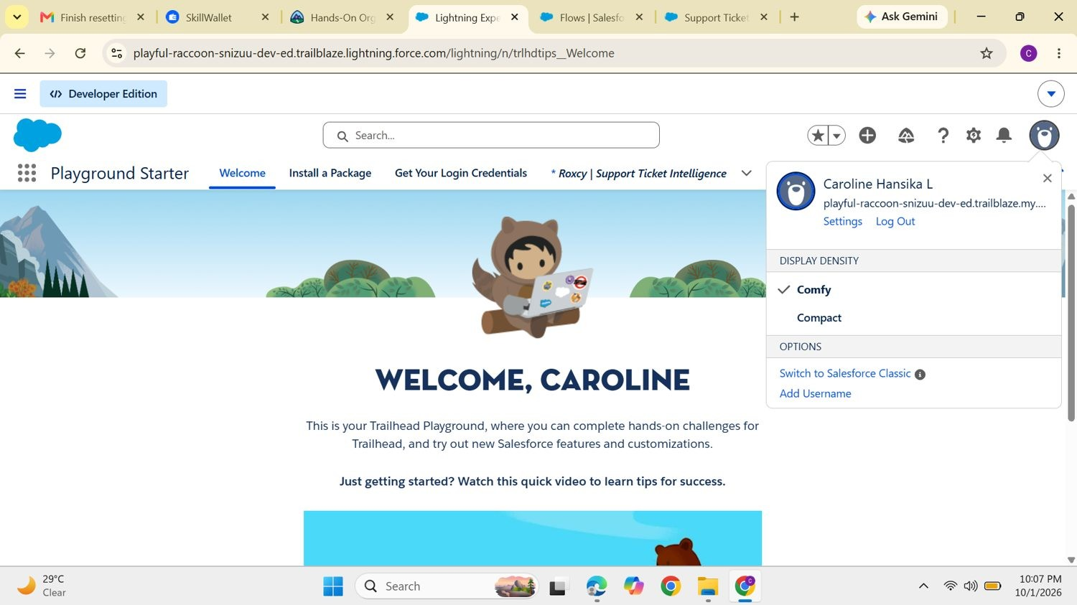
Figure 2. Playground Starter welcome page with the signed-in user menu open.

Activity 3: Open Setup
All configuration in the next milestones is done from Setup. A second Developer Edition org was also set up (sign-up at developer.salesforce.com with name, email, role Developer, company, country and username) for the Agentforce work.
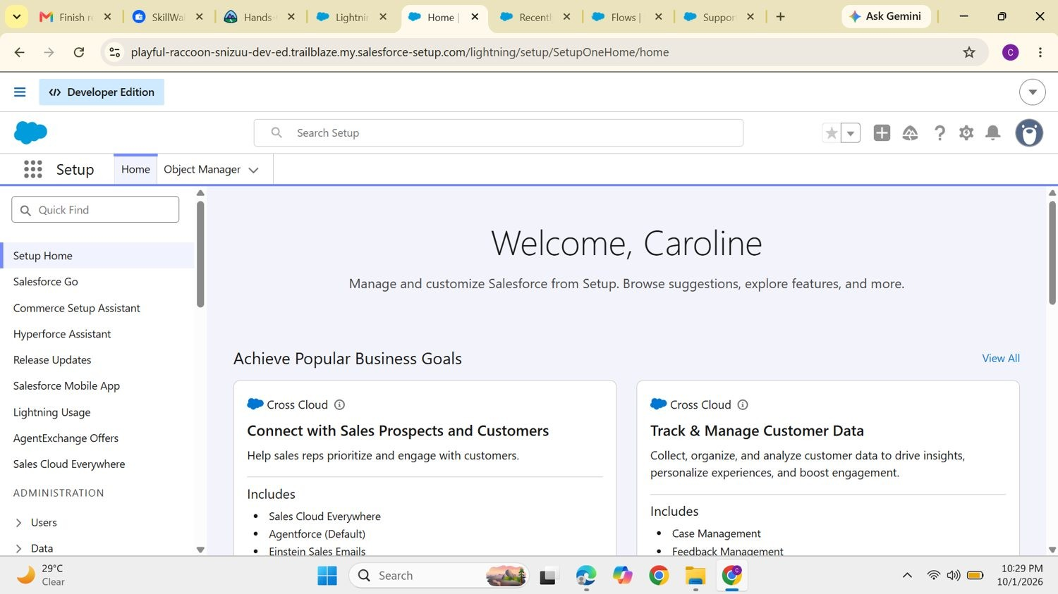
Figure 3.
Setup Home of the Developer Edition org.

Milestone 2: Data Model

Custom object
Property | Value
Object label | Support Ticket Intelligence
API name | Support_Ticket_Intelligence__c
Record name | Ticket Number (Auto Number, format TKT-{0000})

Fields
Field label | API name | Data type | Description
Ticket Number | Ticket_Number__c | Auto Number | TKT-{0000}
Customer | Customer__c | Lookup (Account) | Related Account
Contact | Contact__c | Lookup (Contact) | Customer contact
Issue Type | Issue_Type__c | Picklist | Technical, Billing, General
Description | Description__c | Long Text Area | Issue details
Priority Level | Priority_Level__c | Picklist | Low, Medium, High
Status | Status__c | Picklist | New, In Progress, Resolved
Created Date | Created_Date__c | Date | Ticket date
Assigned To | Assigned_To__c | Lookup (User) | Support agent
SLA Breach Risk | SLA_Breach_Risk__c | Checkbox | Risk flag
Resolution Time (hrs) | Resolution_Time__c | Number | Time taken

Sample records
Test tickets were created so the flow and the agent had data to work on.
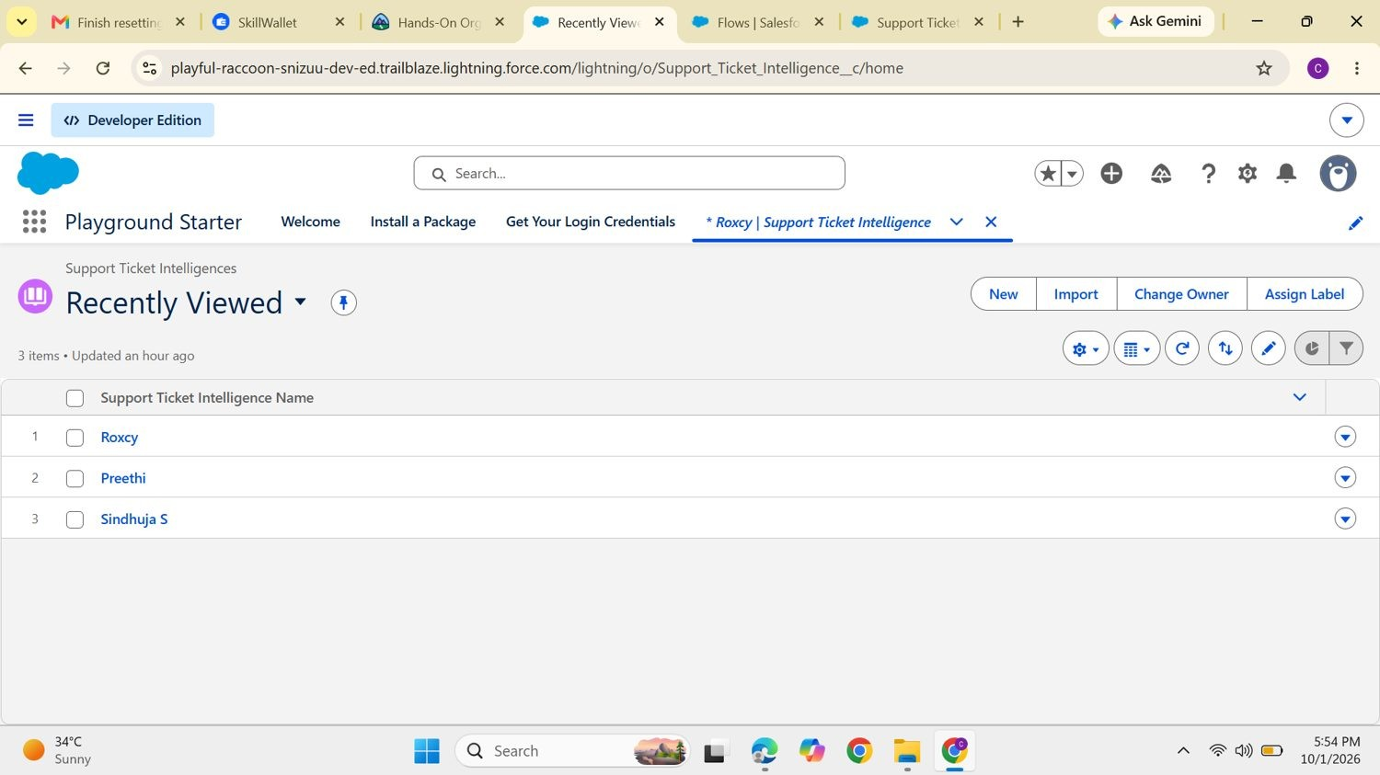
Figure 4. Recently Viewed list of Support Ticket Intelligence records in the Trailhead Playground.
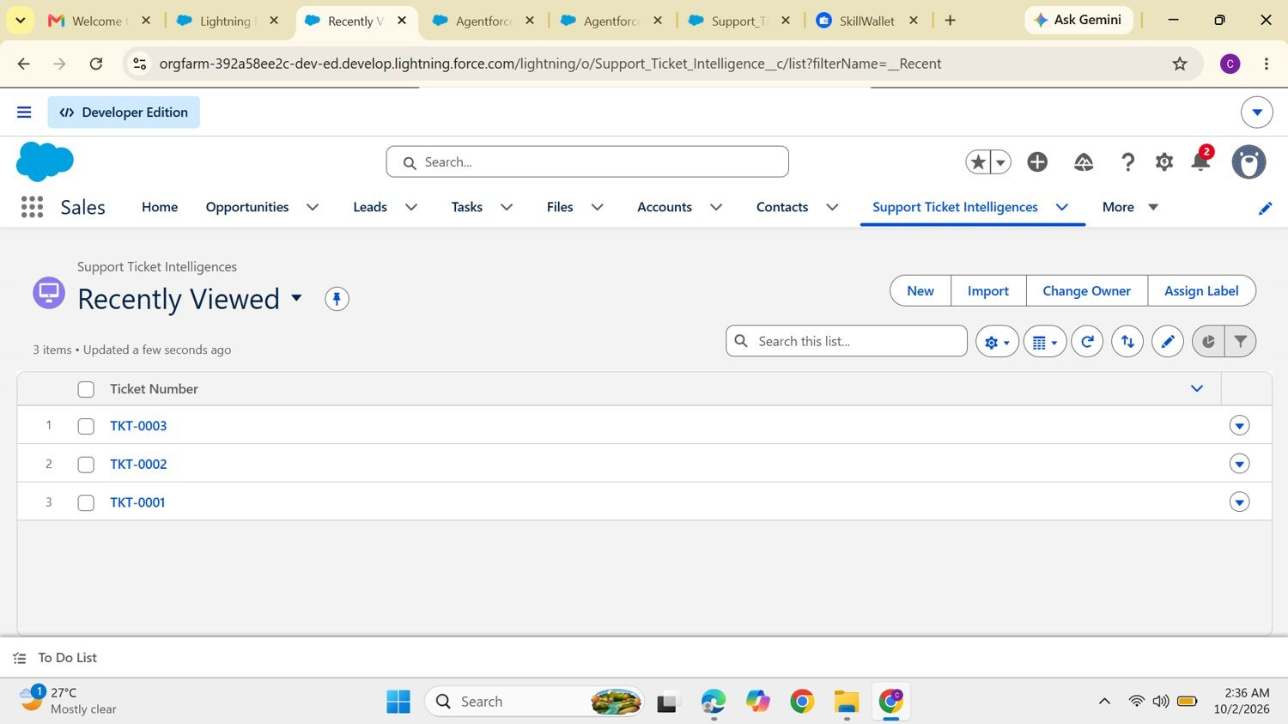
Figure 5. Support Ticket Intelligence list in the Developer Edition org showing TKT-0001, TKT-0002 and TKT-0003.
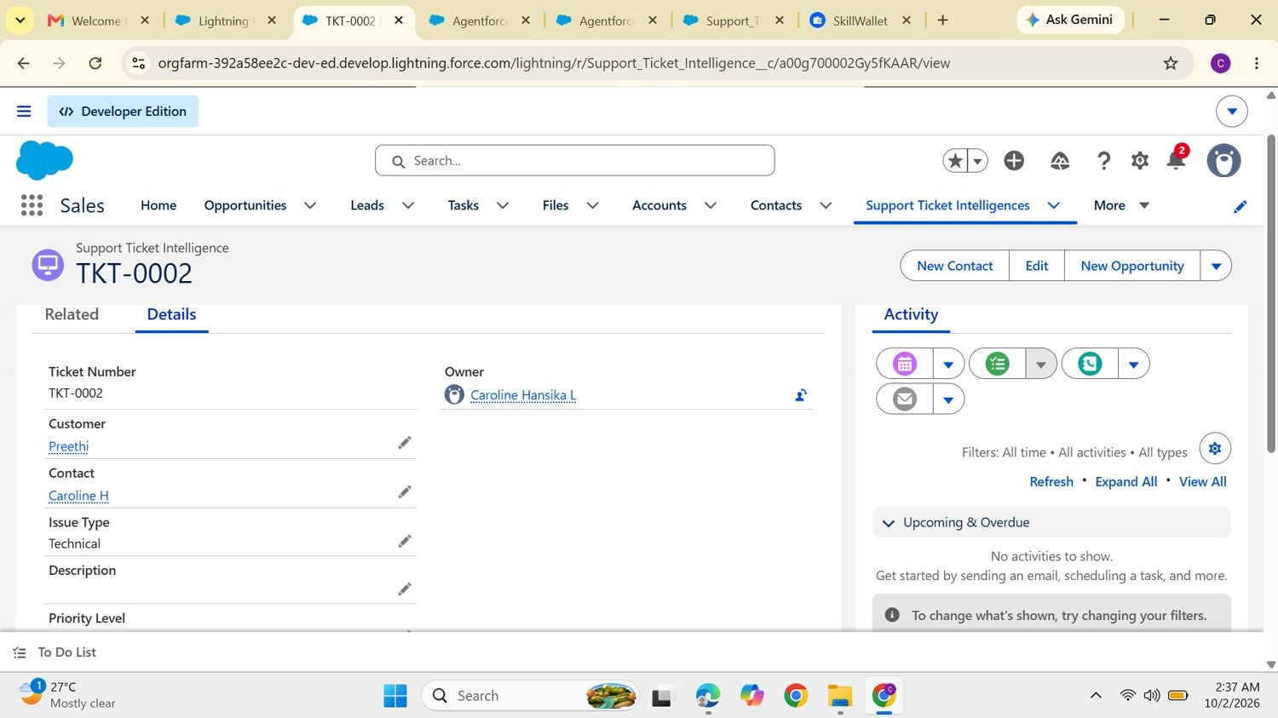
Figure 6. Detail page of ticket TKT-0002: customer, contact, issue type and owner.

Milestone 3: Auto-Launched Flow
The flow takes an Account Name, finds the Account, fetches its latest ticket, checks the description for urgency keywords and returns the priority, the assigned agent and a message. It is an Autolaunched Flow with no trigger so that Agentforce can call it as an action. The flow is saved as Support Ticket Intelligence and appears in the Flows list as an unmanaged, active flow.
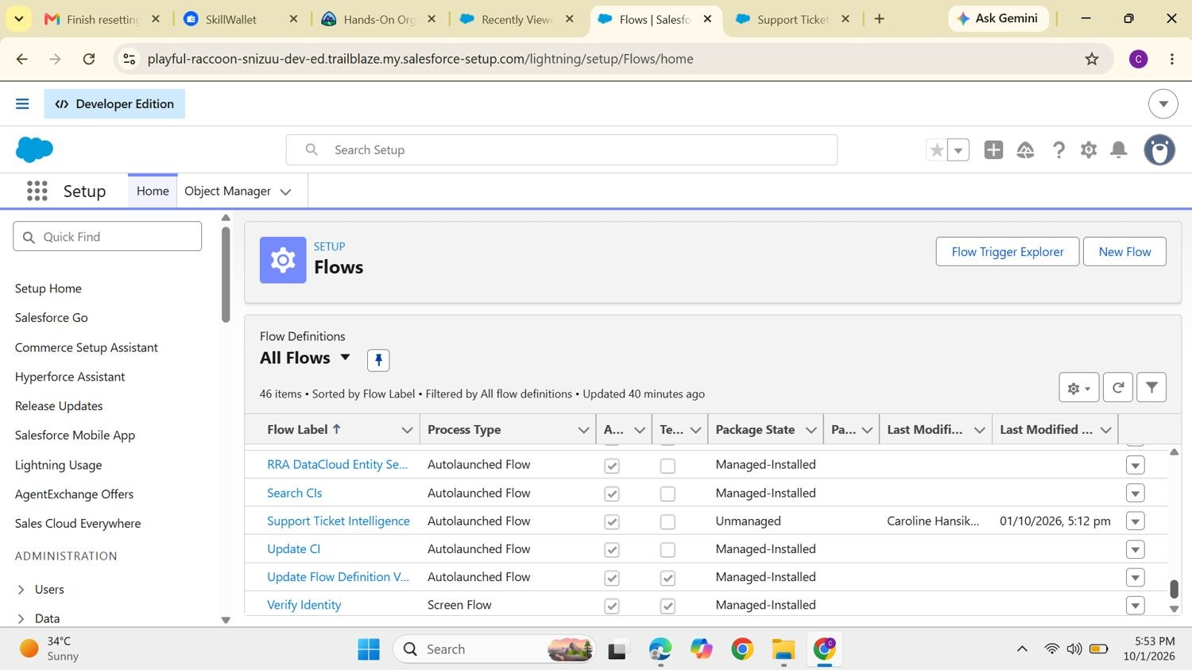
Figure 7. Flows list in Setup showing the Support Ticket Intelligence autolaunched flow.

Flow variables
Label | API name | Type | Direction
Account Name | varAccountName | Text | Input
Account Id | varAccountId | Text | Output
Ticket Id | varTicketId | Text | Output
Priority Level | varPriorityLevel | Text | Output
Assigned Agent | varAssignedTo | Text | Output
Action Message | varActionMessage | Text | Output
In addition, eight flow constants (such as varUrgent, varIssue, varAgent, varSeniorAgent, varMediumAgent, varMediumMessage and varFinalMessage) hold the keywords, agent names and messages used by the flow, so they can be changed in one place.

Flow logic
Step | Element | Configuration
1 | Get Records: Getaccount | Object Account, Name equals {!varAccountName}, sorted by  CreatedDate descending, first record only
2 | Assignment: Store Account Id | varAccountId = Account Id from step 1
3 | Get Records: GetTickets | Object Support_Ticket_Intelligence__c, Customer__c equals  {!varAccountId}, newest first, first record only
4 | Assignment | varTicketId = Id of the ticket found in step 3
5 | Decision: Analyze Description | High: description contains "urgent", "not working" or "failure". Medium:  contains "issue", "slow" or "delay". Default: Low
6 | Assignment: High / Medium / Low  Path | varPriorityLevel is set to High, Medium or Low
7 | Create Records: Create Task (High only) | Subject "Urgent Ticket Handling", WhatId = varTicketId, Priority High, Status Not Started
8 | Assignment: Set Assigned Agent | varAssignedTo = "Senior Support Agent" for High priority
9 | Decision (optional): SLA risk | Flags tickets whose created date is older than two days
10 | Assignment: final message | High: "High priority ticket detected. Assigned to senior agent." Medium:  "Ticket marked as medium priority. Will be handled shortly." Low: "Tickets are low priority and queued for processing."

Flow Builder canvas
The top of the flow retrieves the Account and the ticket and stores their Ids.
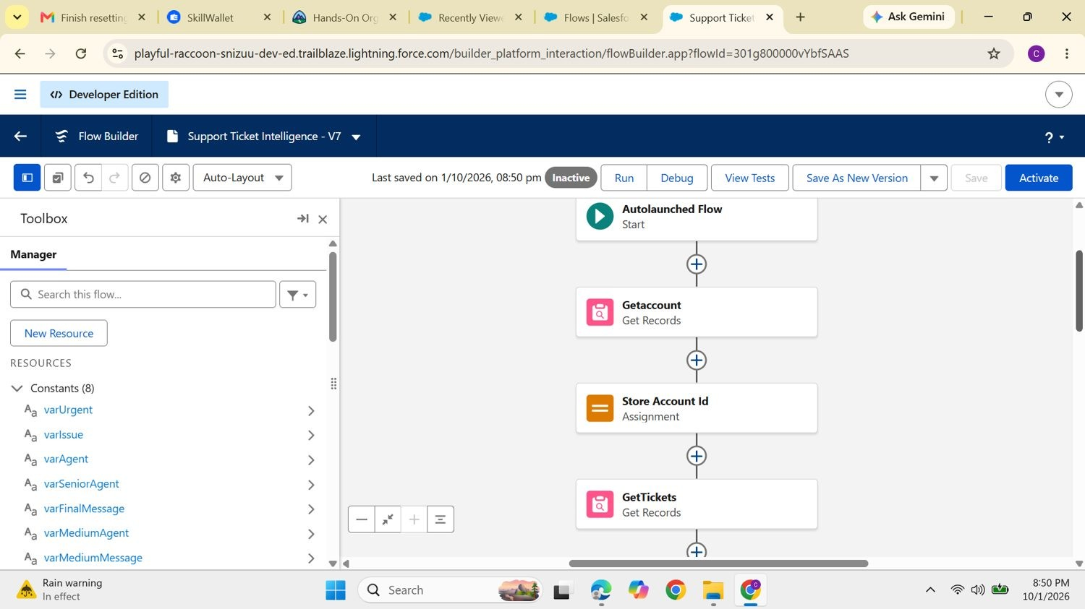
Figure 8. Flow Builder (version 7): Autolaunched Flow start, Getaccount, Store Account Id and GetTickets.
After the Analyze Description decision the flow splits into three paths. The High path creates the task and sets the senior agent, while the Medium and Low paths only set their final messages before ending.
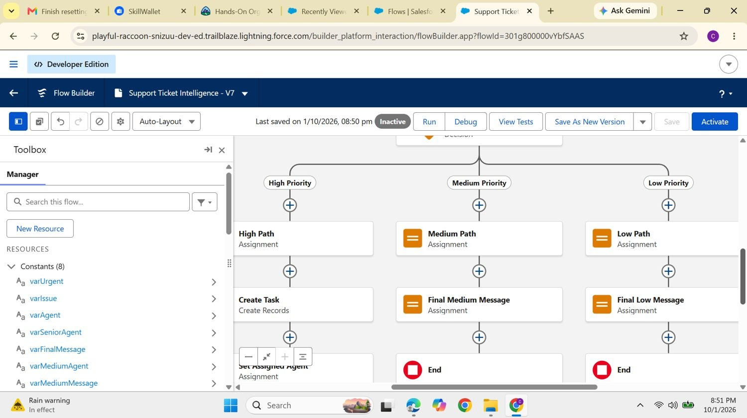
Figure 9. Decision branches for High, Medium and Low priority, with Create Task and Set Assigned Agent on the High path.

Milestone 4: Making the Object Available in the Sales App
To let users open tickets from the Sales app, the object was added to its navigation: Edit navigation items → Add More Items → Support Ticket Intelligences → Save.
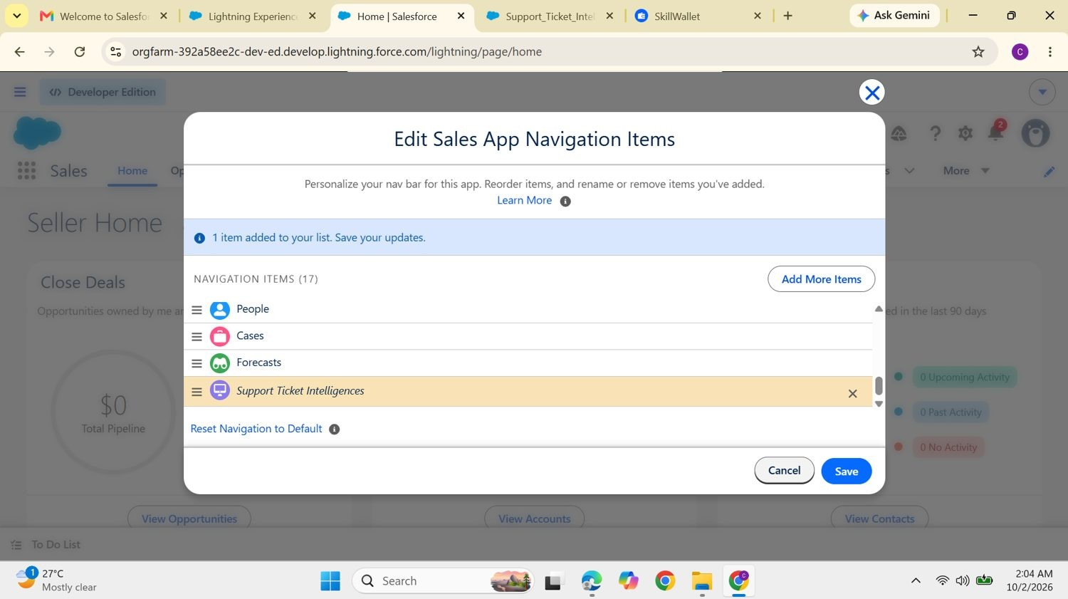
Figure 10. Edit Sales App Navigation Items with Support Ticket Intelligences added to the list.
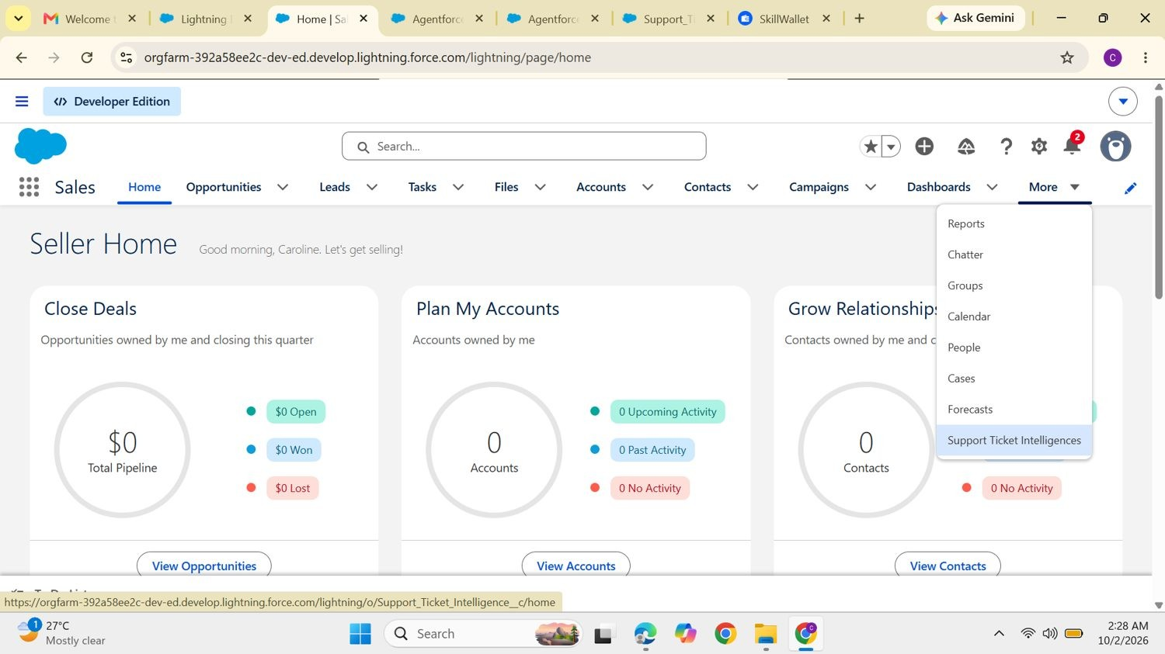
Figure 11. The new tab appears under More in the Sales app navigation bar.

Milestone 5: Agentforce Configuration

Turn on Agentforce
- Open the gear menu and choose Salesforce Go.
- Search for "default", select Agentforce (Default) and open it.
- Choose Get Started → Turn On → Confirm.
- In Setup search for Agents, make sure Agentforce is enabled and open Agentforce (Default).
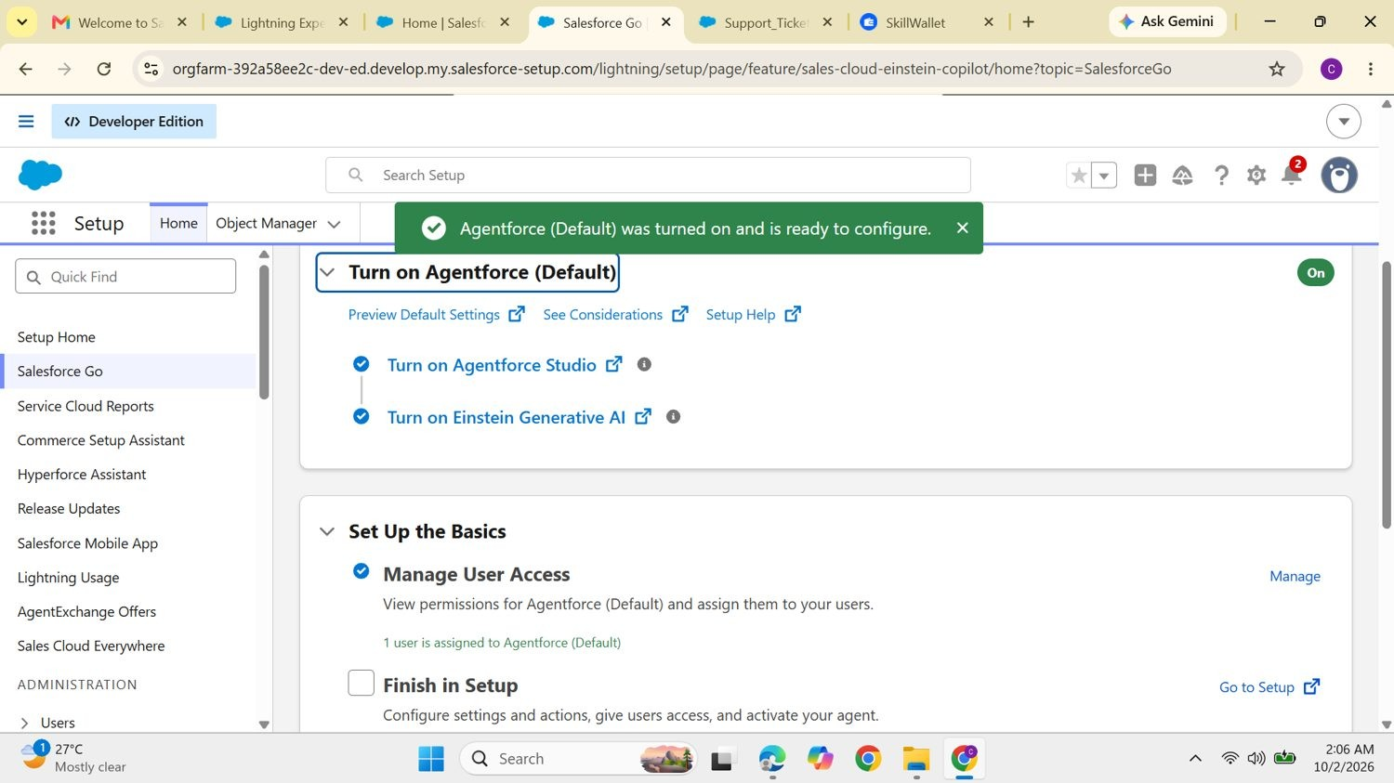
Figure 12. Salesforce Go confirming that Agentforce (Default) was turned on and is ready to configure.

Open the builder and add a subagent
- Select the default agent and click Open in Builder.
- In the Subagents panel click New → New Subagent, then Next.
- Fill in the name, description, scope and instructions given below, then click Next.
- Choose the flow action and click Finish.
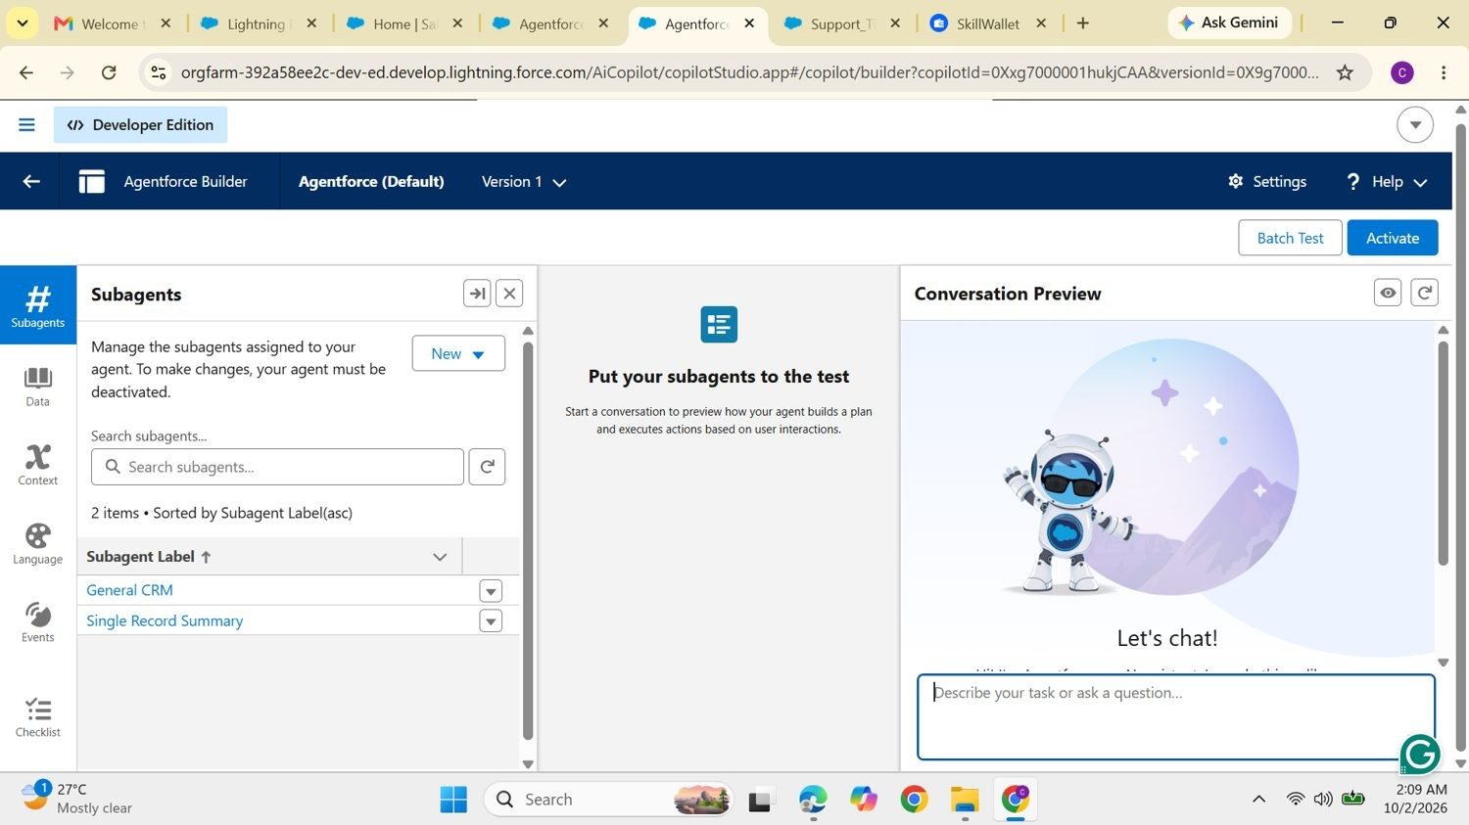
Figure 13. Agentforce Builder for Agentforce (Default), Version 1, with the Subagents panel and the conversation preview.

Subagent configuration
Property | Value
Name | Support Ticket Priority Analysis
API name | Support_Ticket_Priority_Analysis
Classification description | Analyzes customer support tickets to determine priority from the issue description and urgency. Handles requests about ticket status, issue severity and support prioritization.
Scope | Only analyze support ticket descriptions, determine the priority level (High, Medium, Low) and trigger backend automation for task assignment. Do not handle unrelated requests such as billing, subscription management or account updates.

Instructions given to the subagent
- Ask the user for the Account Name if it has not been given.
- Retrieve the latest support ticket associated with the Account.
- Read and analyze the ticket description.
- Decide the priority from keywords: High for "urgent", "not working" or "failure"; Medium for "issue", "slow" or "delay"; otherwise Low.
- Set the priority level accordingly.
- For High priority, trigger the Auto-Launched Flow and make sure an immediate-handling task is created.
- Assign the ticket to the appropriate support level (a senior agent for High priority).
- Reply with a clear message: High means urgent handling has started, Medium means it will be handled shortly, Low means the ticket is queued.
- Never update records directly or send emails; use the Flow for every action.

Agent action
The action references the flow (Reference Action Type: Flow) with the label Support_Ticket_Intelligence__c. Its description reads: Analyzes customer support tickets based on the provided account name, determines ticket priority using issue description, and triggers automation to assign tasks for high-priority cases. Loading text: Analyzing ticket details and determining priority...
Variable | Role | Purpose | Settings
varAccountName | Input | Customer account name used to fetch the latest ticket | Require input and collect from user
varAccountId | Output | Id of the Account used for the lookup | Show in conversation, text
varTicketId | Output | Id of the analyzed ticket | Show in conversation, text
varPriorityLevel | Output | Calculated priority: High, Medium or Low | Show in conversation, text
varAssignedTo | Output | Agent or team assigned to the ticket | Show in conversation, text
varActionMessage | Output | Final message describing priority and actions taken | Show in conversation, text
7
FUNCTIONAL AND PERFORMANCE TESTING
The agent was tested from the Conversation Preview inside Agentforce Builder. The preview also shows the reasoning trace, including which subagent was selected for each message.
Test | Input | Expected result | Evidence
TC-01 | Greeting: "hi" | Agent introduces itself and offers help; a subagent is selected | Figure 14
TC-02 | "let me know about the TKT-0002" | Agent returns a summary of the ticket record | Figure 15
TC-03 | Ticket text containing "urgent",  "not working" or "failure" | Priority High, task created, senior agent assigned | Flow logic, Section 6
TC-04 | Ticket text containing "issue",  "slow" or "delay" | Priority Medium, handled shortly message | Flow logic, Section 6
TC-05 | Ticket text with none of the keywords | Priority Low, queued message | Flow logic, Section 6

Agent greeting
The agent greeted the user and routed the request through the General CRM subagent.
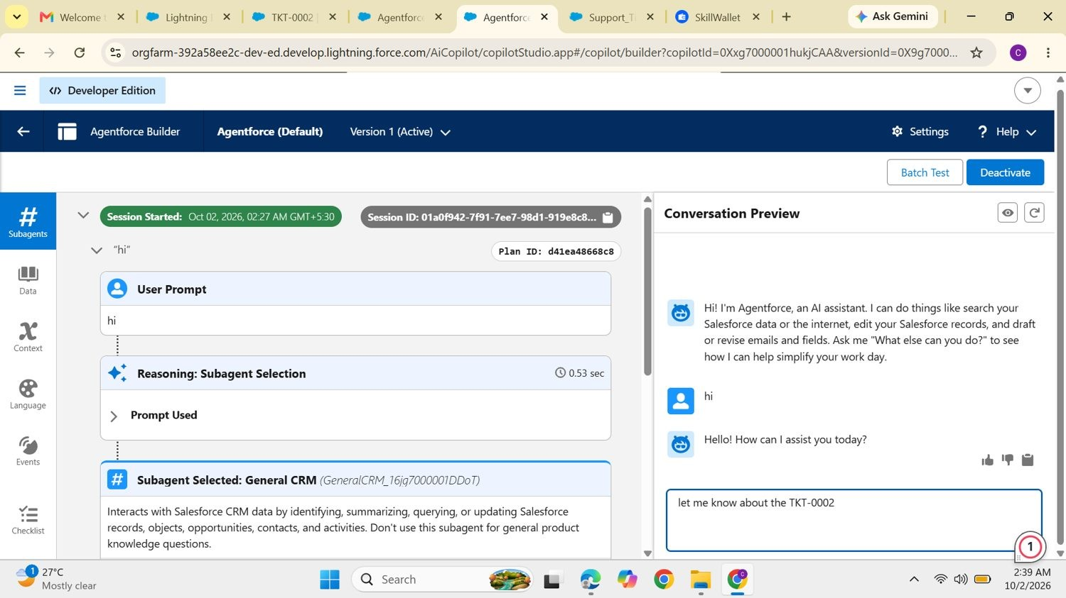
Figure 14. Conversation Preview: greeting, subagent selection and the question "let me know about the TKT-0002".

Ticket summary
For the ticket question, the Single Record Summary subagent was selected. The agent reported that TKT-0002 is owned by Caroline Hansika L, is a technical issue reported by Preethi, has Caroline H as the contact, is In Progress with Medium priority, was created on 10/1/2026 and carries no SLA breach risk.
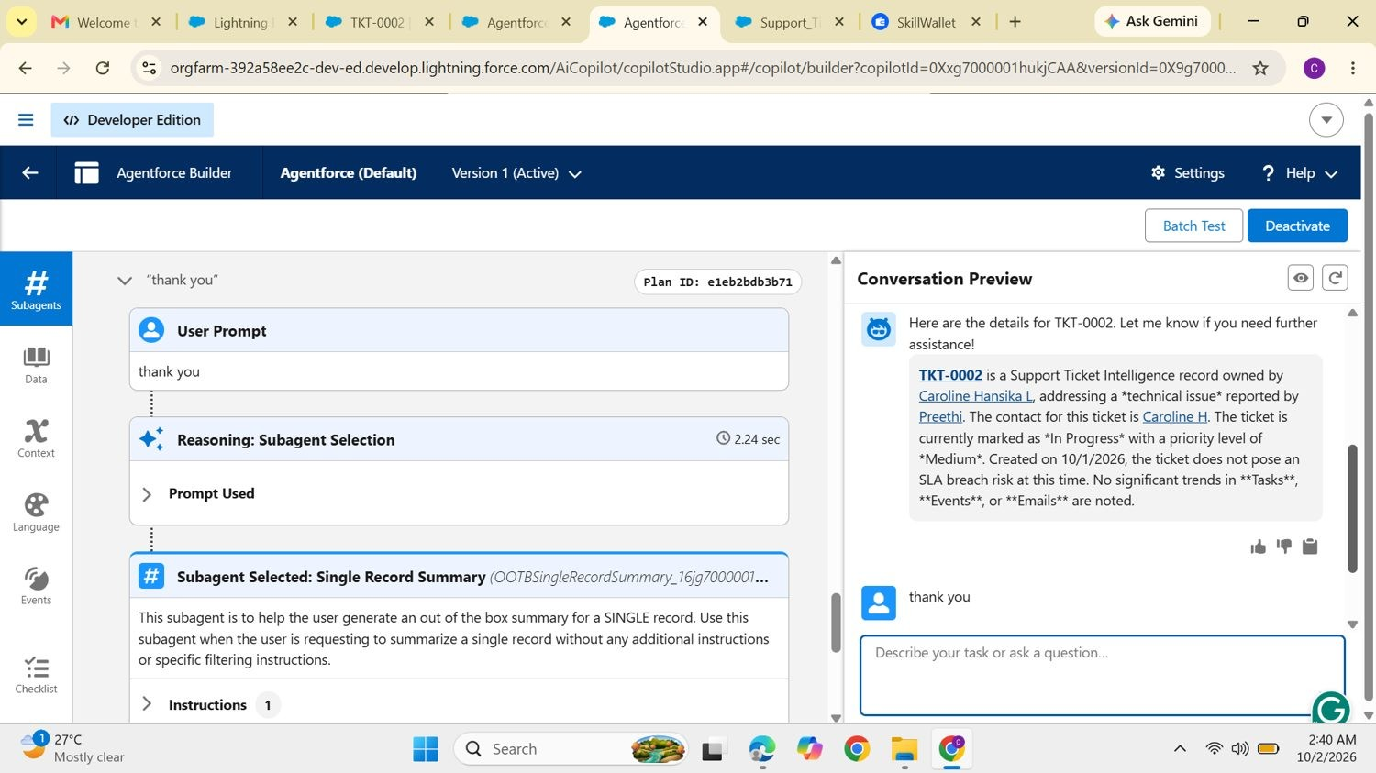
Figure 15. Agentforce response summarizing TKT-0002, with the reasoning trace on the left.
8
ADVANTAGES AND DISADVANTAGES

Advantages
- Automatic prioritization of tickets as High, Medium or Low from the description.
- Faster handling of critical issues because agents see urgent tickets first.
- Less manual effort in analysis, priority setting, task creation and assignment.
- Urgent task creation for every High-priority ticket.
- Better assignment, with High tickets going to a senior agent.
- Conversational access through Agentforce.
- SLA awareness through the optional check on older tickets.
- Scalable with ticket volume through Salesforce automation.
- Higher team productivity as repetitive triage is removed.

Disadvantages
- Keyword-based logic that depends on words such as urgent, not working, failure, issue, slow and delay.
- Limited context understanding; some urgency signals can be missed.
- Depends on accurate data for Account, Contact and ticket details.
- Flow and Agentforce maintenance is needed when requirements change.
- Narrow agent scope; billing and subscription requests are out of scope.
- Limited SLA monitoring; only an optional risk check, not full escalation.
- Assignment rules need expansion for more teams.
- Limited analytics; trend and resolution reporting is future scope.
9
CONCLUSION
The project shows how Salesforce Flow and Agentforce can work together to take the guesswork and repetition out of ticket triage. Given an Account Name, the solution finds the latest ticket, classifies its priority from the description, creates an urgent task for High-priority cases, assigns a support level and replies in plain language. The result is faster handling of critical issues, less manual work and a more productive support team.
10
FUTURE SCOPE
- Add more priority indicators and business rules.
- Return additional ticket information from the Agentforce action.
- Build fuller SLA monitoring and escalation.
- Support more support teams and assignment rules.
- Add analytics for priority trends and resolution performance.
- Add more flow variables and map them in the agent action for richer answers.
11
APPENDIX
Ref | Item | Description
A | Custom object | Support Ticket Intelligence (Support_Ticket_Intelligence__c)
B | Key Salesforce records | Account, Contact, User, Task
C | Flow | Support Ticket Intelligence, Auto-Launched Flow
D | Agentforce subagent | Support Ticket Priority Analysis
E | Agentforce action | Flow-based Support Ticket Intelligence action

